National University of Computer and Emerging Sciences, Lahore Campus

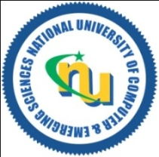 | Course Name: | Calculus and Analytical Geometry | Course Code: | MT1003
 | Degree Program: | BCS 1E and BCS 1F | Semester: | Fall 2023
 | Exam Type: | Practice Questions for Students

Practice Questions for Students
Exercise 2.2
Practice Questions for Students:
Q# 1-50, Q# 63-65
Exercise 2.4
Practice Questions for Students:
Q# 1-4, Q# 11-20, Q# 23-46
Exercise 2.5
Practice Questions for Students:
Q# 1-10, Q# 13-26, Q# 41-46
Exercise 2.6
Practice Questions for Students:
Q# 3-36, Q# 63-72

